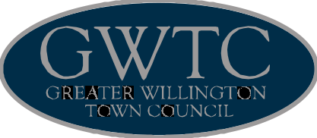
Serving Our Community
67 High Street, Willington, Crook, Co. Durham, DL15 0PF
Town Mayor: Councillor Fraser Tinsley Town Clerk: Mrs Helen Cogdon
Tel: 01388 417725 Email: gwtc@live.co.uk Web: www.gwtc.co.uk

ANNUAL RETURN

 | 31 March  2015 | 31 March  2016 | Please round all figures to nearest pound. Do not leave any boxes blank and report 0 or nil balances.  All figures must agree to Box 7 of previous year.
1.Balances brought  forward | 56912 | 71372
2.(+)Annual  Precept | 76554 | 84018
3.(+) Total other  receipts | 26234 | 44387
4.(-) Staff costs | 37171 | 38168
5.(-) Loan interest/  capital payments | 0 | 0
6.(-)Total other  payments | 51157 | 56846
7.(=)Balances  carried forward | 71372 | 104763
8.Total cash and  short term  investments | 71372 | 104763
9.Total fixed assets  and long term assets | 16800 | 22301
10.Total borrowings | 0 | 0
11.Trust fund  Disclosure note | No | No | The council acts as sole trustee for and is  responsible for managing  - trust fund(s)/assets.  (Readers should  note that the figures above do not  include any trust transactions)

Approved Greater Willington Town Council Meeting 18th May 2016

