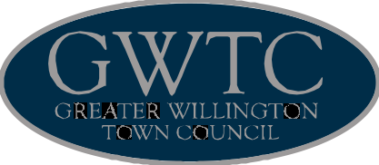
Serving Our Community
91 High Street, Willington, Crook, Co. Durham. DL15 0PE
Town Mayor: Councillor Fraser Tinsley Town Clerk: Mrs Helen Cogdon
t: 01388 417725 gwtc@live.co.uk

ANNUAL RETURN

 | 31 March  2013 | 31 March  2014 | Please round all figures to nearest pound. Do not leave any boxes blank and report 0 or nil balances.  All figures must agree to Box 7 of previous year.
1.Balances brought  forward | 39155 | 54992
2.(+)Annual  Precept | 59500 | 65450
3.(+) Total other  receipts | 16662 | 24755
4.(-) Staff costs | 20553 | 46764
5.(-) Loan interest/  capital payments | 0 | 0
6.(-)Total other  payments | 39772 | 41521
7.(=)Balances  carried forward | 54992 | 56912
8.Total cash and  short term  investments | 54992 | 56912
9.Total fixed assets  and long term assets | 6247 | 8755
10.Total borrowings | 0 | 0
11.Trust fund  Disclosure note | No | No | The council acts as sole trustee for and is  responsible for managing  - trust fund(s)/assets.  (Readers should  note that the figures above do not  include any trust transactions)

Approved Greater Willington Town Council Meeting 7th May 2014

